- <!--Pushpin-->
<!--[GEOS2][skhade][12-02-2020] Change color-->
<!-- previous color = #FF999999 -->
<SolidColorBrush x:Key="{dxt:MapBrushesThemeKey ResourceKey=PushpinBackground}" Color="#FF8AFBFF"/>
<!-- previous color = #FF373A3D -->
<SolidColorBrush x:Key="{dxt:MapBrushesThemeKey ResourceKey=PushpinForeground}" Color="#FF8AFBFF"/>
<!-- previous color = #FF083493 -->
<SolidColorBrush x:Key="{dxt:MapBrushesThemeKey ResourceKey=PushpinSelectionBrush}" Color="#FFFF0000"/>
<!-- previous color = #FFFFFFFF -->
<SolidColorBrush x:Key="{dxt:MapBrushesThemeKey ResourceKey=PushpinSelectionForeground}" Color="#FFFF0000"/>

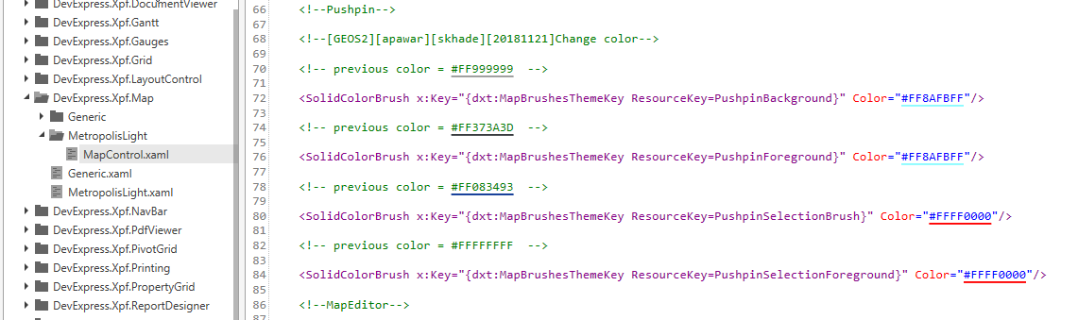

- <Style x:Key="{dxdst:DefaultStyleThemeKey FullName=DevExpress.Xpf.WindowsUI.MenuFlyoutItem}" TargetType="{x:Type dxwui:MenuFlyoutItem}">
<Setter Property="Background"
Value="Transparent"
cs:id="Setter_0000"/>
<Setter Property="Foreground" Value="{DynamicResource ResourceKey={dxwuit:MenuFlyoutElementsThemeKey ResourceKey=Foreground}}"/>
<Setter Property="Margin" Value="{DynamicResource ResourceKey={dxwuit:MenuFlyoutElementsThemeKey ResourceKey=SelectionPadding}}"/>
<Setter Property="Padding" Value="{DynamicResource ResourceKey={dxwuit:MenuFlyoutElementsThemeKey ResourceKey=Padding}}"/>
<Setter Property="FontSize" Value="{DynamicResource ResourceKey={dxwuit:MenuFlyoutElementsThemeKey ResourceKey=FontSize}}"/>
<Setter Property="FocusVisualStyle" Value="{x:Null}"/>
<Setter Property="Template">
<Setter.Value>
<ControlTemplate TargetType="dxwui:MenuFlyoutItem">
<Grid x:Name="Root"
Background="{TemplateBinding Background}"
SnapsToDevicePixels="{TemplateBinding SnapsToDevicePixels}">
<VisualStateManager.VisualStateGroups>
<VisualStateGroup x:Name="CommonStates">
<VisualState x:Name="MouseOver">
<Storyboard>
<!--[GEOS2][skhade][12-02-2020] [Set DoubleAnimation Duration="0" To="0"]-->
<DoubleAnimation Duration="0"
Storyboard.TargetName="HoverState"
Storyboard.TargetProperty="Opacity"
To="0"/>
<ObjectAnimationUsingKeyFrames Storyboard.TargetName="content" Storyboard.TargetProperty="Foreground">
<DiscreteObjectKeyFrame KeyTime="0" Value="{DynamicResource ResourceKey={dxwuit:MenuFlyoutElementsThemeKey ResourceKey=SelectedForeground}}"/>
</ObjectAnimationUsingKeyFrames>
</Storyboard>
</VisualState>
<VisualState x:Name="Pressed">
<Storyboard>
<!--[GEOS2][skhade][12-02-2020] [Set DoubleAnimation Duration="0" To="0"]-->
<DoubleAnimation Duration="0"
Storyboard.TargetName="PressedState"
Storyboard.TargetProperty="Opacity"
To="0"/>
<ObjectAnimationUsingKeyFrames Storyboard.TargetName="content" Storyboard.TargetProperty="Foreground">
<DiscreteObjectKeyFrame KeyTime="0" Value="{DynamicResource ResourceKey={dxwuit:MenuFlyoutElementsThemeKey ResourceKey=PressedForeground}}"/>
</ObjectAnimationUsingKeyFrames>
</Storyboard>
</VisualState>
<VisualState x:Name="Disabled">
<Storyboard>
<DoubleAnimation Duration="0"
Storyboard.TargetName="Root"
Storyboard.TargetProperty="Opacity"
To="0.35"/>
</Storyboard>
</VisualState>
<VisualState x:Name="Normal"/>
</VisualStateGroup>
</VisualStateManager.VisualStateGroups>
<!--[GEOS2][skhade][12-02-2020][Set HoverState Background from ="{DynamicResource ResourceKey={dxwuit:MenuFlyoutElementsThemeKey ResourceKey=SelectedBackground}}" to ="Transparent"]-->
<Border x:Name="HoverState"
Background="Transparent"
Opacity="0"
cs:id="Border_0000"/>
<Border x:Name="PressedState"
Background="{DynamicResource ResourceKey={dxwuit:MenuFlyoutElementsThemeKey ResourceKey=PressedBackground}}"
Opacity="0"/>
<dxwuii:MenuFlyoutItemContentPresenter x:Name="content"
Content="{TemplateBinding Content}"
ContentTemplate="{TemplateBinding ContentTemplate}"
ContentTemplateSelector="{TemplateBinding ContentTemplateSelector}"
Focusable="False"
Foreground="{TemplateBinding Foreground}"
HorizontalAlignment="{TemplateBinding HorizontalContentAlignment}"
Margin="{TemplateBinding Padding}"
VerticalAlignment="{TemplateBinding VerticalContentAlignment}"/>
</Grid>
</ControlTemplate>
</Setter.Value>
</Setter>
</Style>
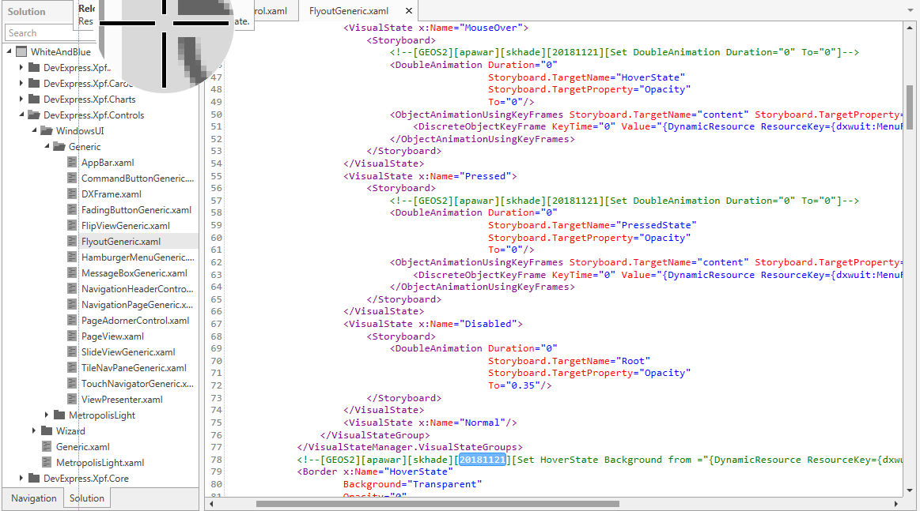

- <Style x:Key="{dxdst:DefaultStyleThemeKey FullName=DevExpress.Xpf.WindowsUI.PageView}" TargetType="{x:Type dxwui:PageView}">
<Setter Property="Template" Value="{DynamicResource {dxwuit:PageViewElementsThemeKey ResourceKey=Template}}"/>
<Setter Property="TemplateRight" Value="{DynamicResource {dxwuit:PageViewElementsThemeKey ResourceKey=TemplateRight}}"/>
<Setter Property="TemplateLeft" Value="{DynamicResource {dxwuit:PageViewElementsThemeKey ResourceKey=TemplateLeft}}"/>
<Setter Property="TemplateTop" Value="{DynamicResource {dxwuit:PageViewElementsThemeKey ResourceKey=Template}}"/>
<Setter Property="TemplateBottom" Value="{DynamicResource {dxwuit:PageViewElementsThemeKey ResourceKey=TemplateBottom}}"/>
<Setter Property="ItemsPanel" Value="{DynamicResource {dxwuit:PageViewElementsThemeKey ResourceKey=ItemsPanel}}"/>
<Setter Property="Background" Value="{DynamicResource {dxwuit:PageViewElementsThemeKey ResourceKey=Background}}"/>
<!--[GEOS2][skhade][12-02-2020][Set pading to 0]-->
<Setter Property="Padding" Value="0,0,0,0"/>
<!--SPECIFICTHEME VS2010 <Setter Property="Foreground" Value="{DynamicResource {dxwuit:PageViewElementsThemeKey ResourceKey=Foreground}}" /> SPECIFICTHEME-->
</Style>
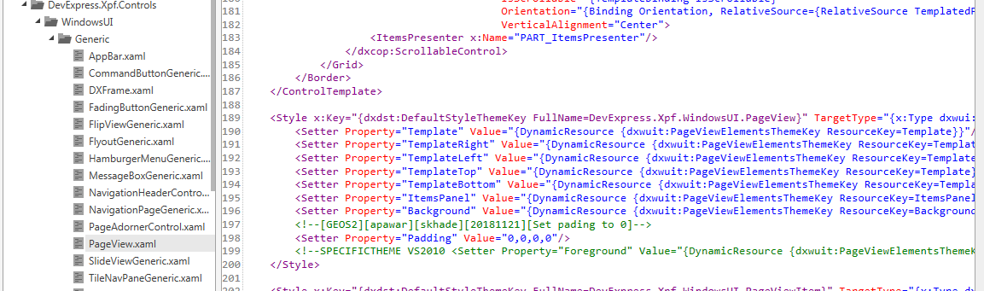

- <!--TileBar-->
<Style x:Key="{dxdst:DefaultStyleThemeKey FullName=DevExpress.Xpf.Navigation.TileBar}" TargetType="dxnav:TileBar">
<Setter Property="dxcop:ScrollableControl.ScrollButtonMode" Value="Default"/>
<!--[GEOS2][skhade][12-02-2020][Set padding from ="20,30,20,20" to "20,6,0,5"]-->
<Setter Property="Padding" Value="20,6,0,5"/>
<Setter Property="Template">
<Setter.Value>
<ControlTemplate TargetType="dxnav:TileBar">
<Border Background="{TemplateBinding Background}"
BorderBrush="{TemplateBinding BorderBrush}"
BorderThickness="{TemplateBinding BorderThickness}">
<Grid>
<dxcop:FlyoutDecorator x:Name="PART_TileNavFlyoutDecorator" FlyoutShowMode="{TemplateBinding FlyoutShowMode}"/>
<dxcop:ScrollableControl x:Name="PART_ScrollableControl"
Orientation="{TemplateBinding Orientation}"
ScrollButtonMode="{Binding Path=(dxcop:ScrollableControl.ScrollButtonMode), RelativeSource={RelativeSource TemplatedParent}}">
<ItemsPresenter x:Name="PART_ItemsPresenter"/>
</dxcop:ScrollableControl>
</Grid>
</Border>
</ControlTemplate>
</Setter.Value>
</Setter>
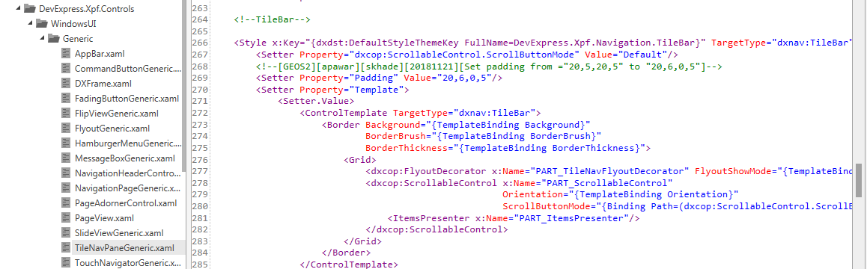

- <!--[GEOS2][apawar][skhade][20181121][Set backBrushPressed to Transparent]-->
<SolidColorBrush x:Key="backBrushPressed" Color="Transparent"/>
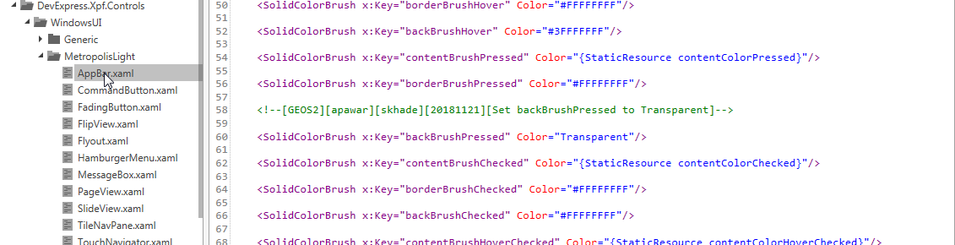

- <!-- Glyph -->
<DataTemplate x:Key="{dxwuit:CommandButtonElementsThemeKey ResourceKey=BackGlyph}">
<!--[GEOS2][skhade][12-02-2020] [Modify Width="27" to "15" Height="25" to "12"]-->
<Path Data="F1 M 305,875L 305,874L 317,862L 321,862L 310,873L 332,873L 332,876L 310,876L 321,887L 317,887L 305,875 Z "
Height="12"
Stretch="Fill"
Width="15"/>
</DataTemplate>
<!-- Glyph -->
<DataTemplate x:Key="{dxwuit:CommandButtonElementsThemeKey ResourceKey=ForwardGlyph}">
<!--[GEOS2][skhade][12-02-2020] [modify Width="27" to "15" Height="25" to "12"]-->
<Path Data="F1 M 305,875L 305,874L 317,862L 321,862L 310,873L 332,873L 332,876L 310,876L 321,887L 317,887L 305,875 Z "
Height="12"
RenderTransformOrigin="0.5,0.5"
Stretch="Fill"
Width="15">
<Path.RenderTransform>
<ScaleTransform ScaleX="-1"/>
</Path.RenderTransform>
</Path>
</DataTemplate>

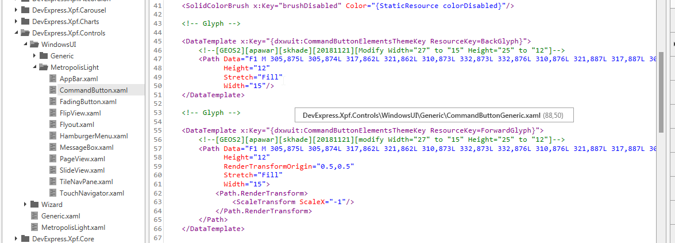

- <!-- Template -->
<ControlTemplate x:Key="{dxwuit:CommandButtonElementsThemeKey ResourceKey=Template}" TargetType="dxwui:CommandButton">
<Grid SnapsToDevicePixels="True">
<!--[GEOS2][skhade][12-02-2020] [Modify size of Ellipse MinHeight=20 and MinWidth=20]-->
<Ellipse x:Name="border"
Fill="{StaticResource ellipseFillDefault}"
MinHeight="20"
MinWidth="20"
Stroke="{StaticResource ellipseStrokeDefault}"
StrokeThickness="3"
UseLayoutRounding="True">
<dxi:Interaction.Behaviors>
<dxwuii:ConstrainedSizeBehavior/>
</dxi:Interaction.Behaviors>
</Ellipse>
<dxwuii:ShapeContentPresenter x:Name="content"
Foreground="{StaticResource pathColorDefault}"
HorizontalAlignment="Center"
VerticalAlignment="Center"/>
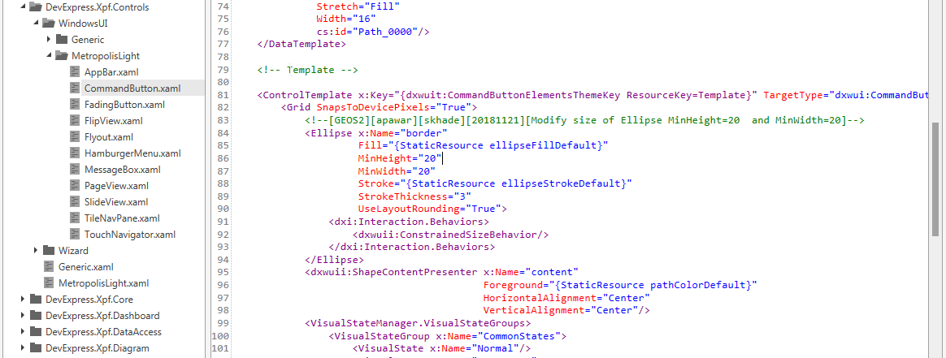

- <!--[GEOS2][skhade][12-02-2020] [Set color for ItemHoverBackground and ItemSelectionBackground]-->
<SolidColorBrush x:Key="ItemHoverBackground" Color="#FF3366CC"/>
<SolidColorBrush x:Key="ItemSelectionBackground" Color="#FF3366CC"/>
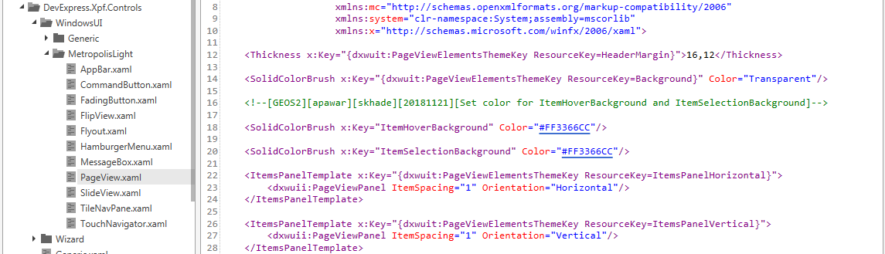

- <ControlTemplate x:Key="{dxbt:BarItemBorderInMenuThemeKey ResourceKey=Normal}" TargetType="{x:Type dxb:ItemBorderControl}">
<Grid x:Name="Root" SnapsToDevicePixels="True">
<Grid>
<!--[GEOS2][skhade][12-02-2020][change Background from "#FFFFFFFF"/#FF083493 to "#FFB9B9B9"] -->
<Border x:Name="HoverState" Opacity="0">
<Border x:Name="hover"
Background="#FFB9B9B9"
Opacity="0"
cs:id="Border_0000"/>
</Border>
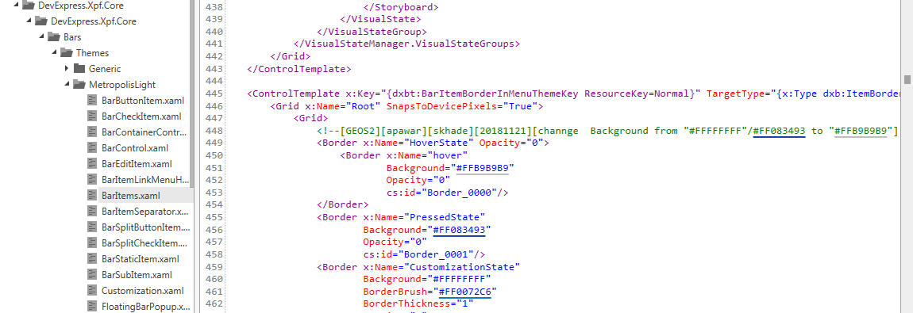

- <DockPanel Name="PART_HeaderDock"
LastChildFill="True"
Margin="{DynamicResource {dxt:FloatingContainerThemeKey ResourceKey=FloatingContainerHeaderDockMargin}}">
<Image x:Name="PART_Icon"
DockPanel.Dock="Left"
Source="{Binding Path=(dxc:FloatingContainer.FloatingContainer).Icon, RelativeSource={RelativeSource AncestorType=ContentPresenter}}"
Style="{DynamicResource {dxt:FloatingContainerThemeKey ResourceKey=DXWindowIconStyle}}"/>
<Grid x:Name="PART_Grid"
DockPanel.Dock="Right"
Focusable="False"
UseLayoutRounding="True">
<!-- [GEOS2][skhade][12-02-2020] [20181121][Added Margin="0,-5,0,0"]-->
<ItemsControl Margin="0,-5,0,0"
Style="{DynamicResource {dxt:DXTabbedWindowThemeKey ResourceKey=ButtonContainerStyle}}"
Visibility="Hidden">
<dxc:HeaderItemControl DockPanel.Dock="Right" Style="{DynamicResource {dxt:FloatingContainerThemeKey ResourceKey=FloatingContainerHeaderCloseButtonStyle}}"/>
</ItemsControl>
<!-- [GEOS2][skhade][12-02-2020] [Added Margin="0,-5,0,0"]-->
<ItemsControl x:Name="PART_HeaderButtons"
Focusable="False"
IsTabStop="False"
Margin="0,-5,0,0"
Style="{DynamicResource {dxt:DXTabbedWindowThemeKey ResourceKey=ButtonContainerStyle}}">
<dxc:HeaderItemControl x:Name="PART_CloseButton"
DockPanel.Dock="Right"
Style="{DynamicResource {dxt:FloatingContainerThemeKey ResourceKey=FloatingContainerHeaderCloseButtonStyle}}"
Visibility="Collapsed"/>
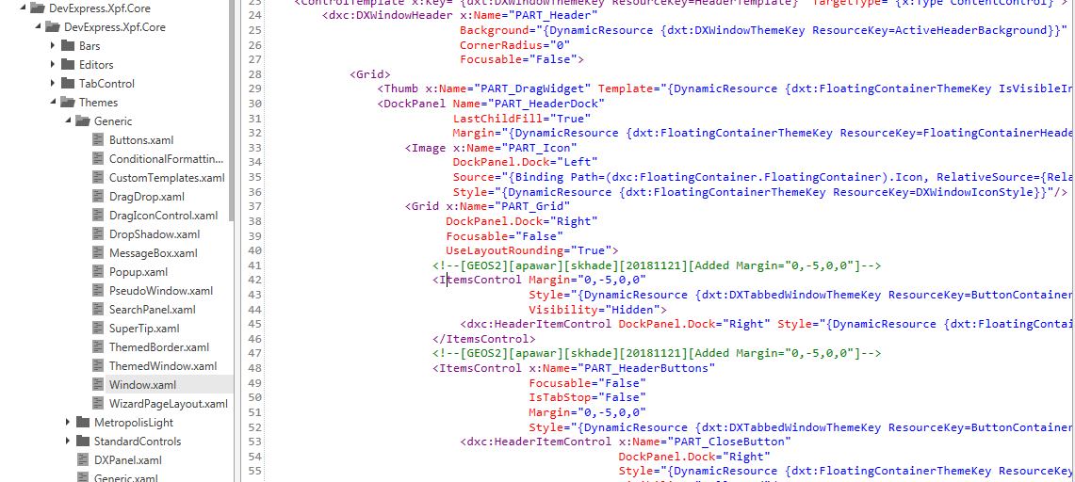

- <!--[GEOS2][skhade][12-02-2020] Change color From #BFFFFFFF/#FF373A3D to #FF000000 -->
<SolidColorBrush x:Key="{dxdst:ThemeColorsThemeKey ResourceKey=DXMessageBoxForegroundColor}" Color="#FF000000"/>
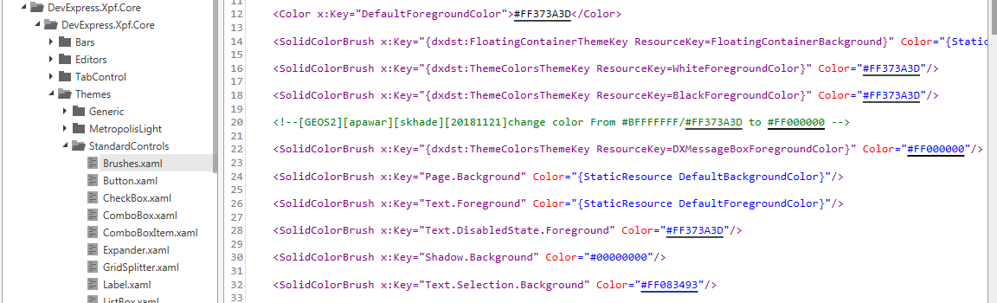

- <!--Thickness-->
<!--[GEOS2][skhade][12-02-2020][Set all thickness 0]-->
<Thickness x:Key="{dxt:DXWindowThemeKey ResourceKey=ResizeBorderThickness}">0</Thickness>
<Thickness x:Key="{dxt:DXWindowThemeKey ResourceKey=BorderEffectOffset}">0</Thickness>
<Thickness x:Key="{dxt:DXWindowThemeKey ResourceKey=BorderEffectLeftMargins}">0, 0, 0, 0</Thickness>
<Thickness x:Key="{dxt:DXWindowThemeKey ResourceKey=BorderEffectRightMargins}">0, 0, 0, 0</Thickness>
<Thickness x:Key="{dxt:DXWindowThemeKey ResourceKey=BorderEffectTopMargins}">0</Thickness>
<Thickness x:Key="{dxt:DXWindowThemeKey ResourceKey=BorderEffectBottomMargins}">0</Thickness>
<Thickness x:Key="{dxt:DXWindowThemeKey ResourceKey=SizeGripMargin}">0,0,0,0</Thickness>
<Thickness x:Key="{dxt:DXWindowThemeKey ResourceKey=FloatingContainerBodyMargin}">0,0,0,0</Thickness>
<Thickness x:Key="{dxt:DXWindowThemeKey ResourceKey=FloatingContainerBorderPadding}">0</Thickness>
<Thickness x:Key="{dxt:FloatingContainerThemeKey ResourceKey=FloatingContainerHeaderDockMargin}">0,0,0,0</Thickness>
<Thickness x:Key="{dxt:FloatingContainerThemeKey ResourceKey=HeaderItemsControlMargin}">0</Thickness>
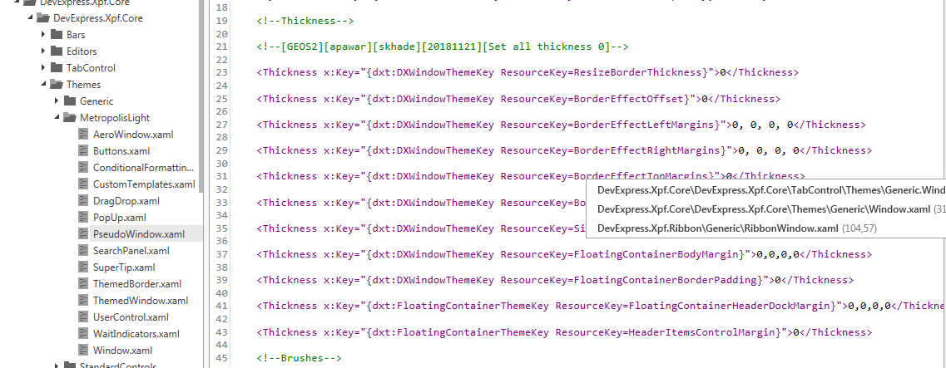

- <!--[GEOS2][skhade][12-02-2020][Change color from #FFB9B9B9 to #FF083493 ]-->
<SolidColorBrush x:Key="UnfocusedRowBrush" Color="#FF083493"/>
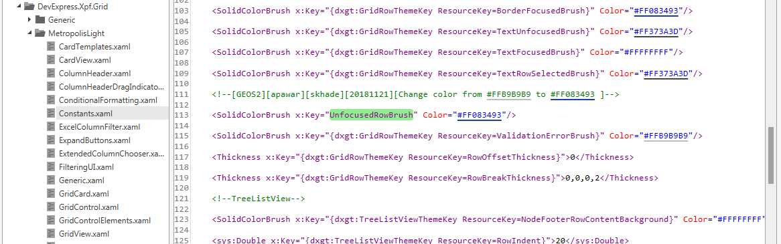

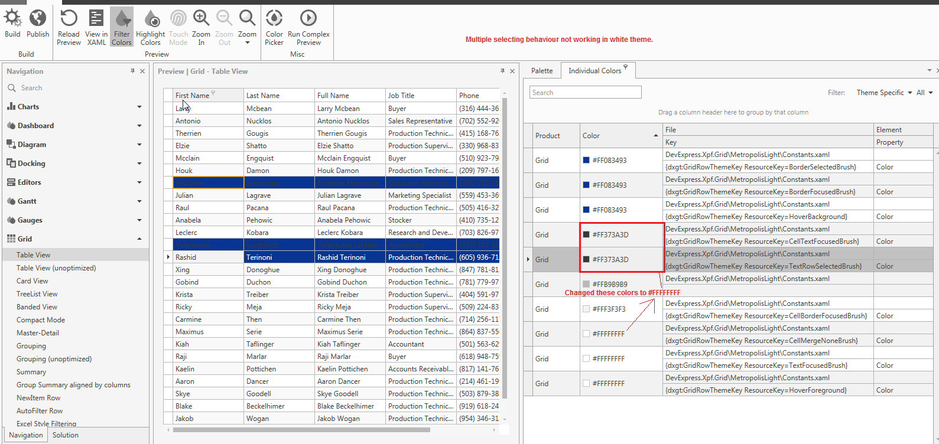

- CellBrushSchema.Default Changed to #FFFFFFFF

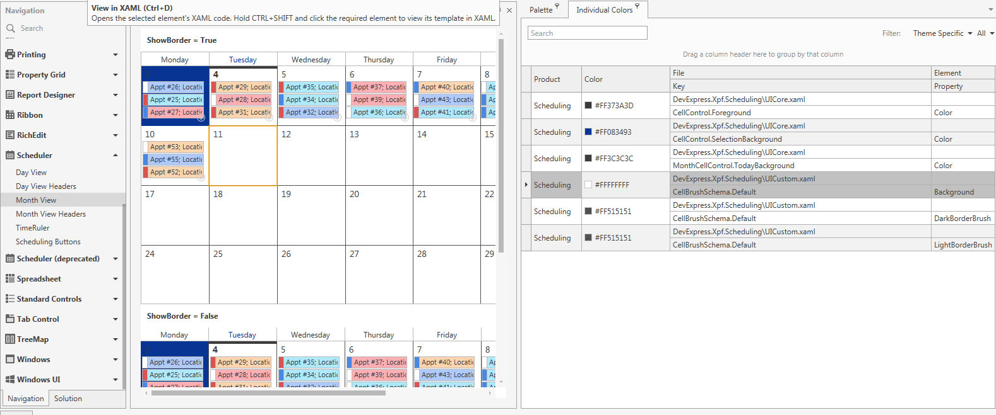

15.

